Abstract guidance for all submissions that require an abstract
A. First,^{a,b} B. Anotherone,ª G. E. Presenting,^{a,c} and K. B. Lastª
a: University of City_L, Country_X;
b: Big University of Science, Uni_Town_M Country_Y;
c: Spin Institute, Town_N, Country_Z.
Every author knows (or should know) best how to prepare their abstract in order to convey their message to the audience in the most efficient way. So, this template is provided to aid the task of preparing your submission, rather than as a prescription for what to do. Its pdf is posted online to show where your abstracts would be located once accepted; in MS Word, it will be available once you log in to your account. The content and form of your abstract is your sole responsibility, and you can, of course, use any software to produce your abstract and then submit the resulting pdf file. As a guide, the abstract (excluding references [,] and acknowledgements) should fit within one A4 page, be legible and reasonably formatted (in a broad sense), be relevant, and contain (i) the current TRTM header; (ii) title; (iii) author names, each with all affiliations; and (iv) body (even if just a sentence).
During submission, you will need to indicate the format of your presentation as one of the following.
Posters:
a complete result – a report on a complete research study of significant scientific value;
a preliminary report – for ongoing research that would benefit from further discussion and insights;
a new project, team, or laboratory – for a presentation of a new (typically, collaborative) research project, or a newly established laboratory / team and their roadmap.
Self-nominations for invited talks:
an in-depth report of a recent discovery or discoveries; a roadmap; or a tutorial.
You can add supplementary data to your submission: upload a file directly on the platform, retrieve a document available from the URL or embed html code (e.g. video deposited elsewhere).
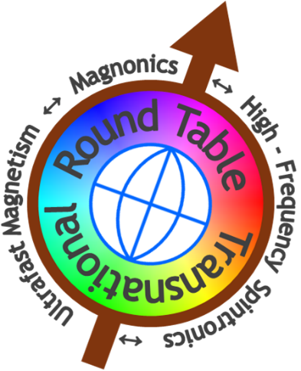
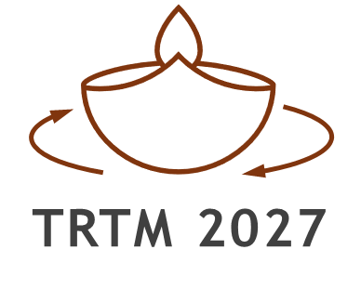
To participate in TRTM without giving a presnetation, simply email the TRTM secretary to inform us about your intention.
Fig. 1. (left) TRTM logo: the arrow symbolises a spin; its tilt hints at that of the rotation axis of the Earth shown by the globe; the colour wheel may denote either the azimuth, or phase (of rotation, precession, oscillation, wave), or the equality, diversity, and inclusion as the TRTM’s core values. The dominance of the round shapes and axial symmetry stress the Round Table format of the conference.
(right) TRTM 2027 logo: the diya symbolises the triumph of light over darkness and knowledge over ignorance; here, it is spinning as a reference to the angular momentum, spin, and spin physics, or perhaps to the cyclic nature of life and research.

[] B. Anotherone, et al, Realisation of an ultrafast nanoscale all-magnon device for super-pooper computing, J. High-Impact Research 111, 222333 (2019).
[] K. B. Thoroughly, M. Modest, and J. Omniunknown, Technology that might make ultrafast nanoscale all-magnon devices feasible, J. Reproducible Results 12, 345678 (2029).

